CREATE NODE-RED SERVICES

|  |  |
| --- | --- |
| Team ID | PNT2022TMID48082 |
| Project Name | SMART WASTE MANANGEMENT SYSTEM FOR METROPOLITAN CITIES  – IOT |

DOWNLOAD AND INSTALL NODE.JS :

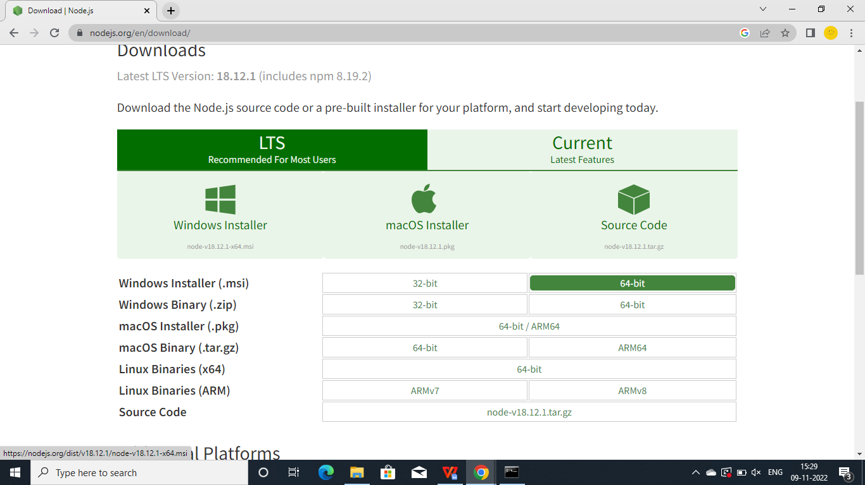

AFTER INSTALL,OPEN Node.js COMMAND PROMT

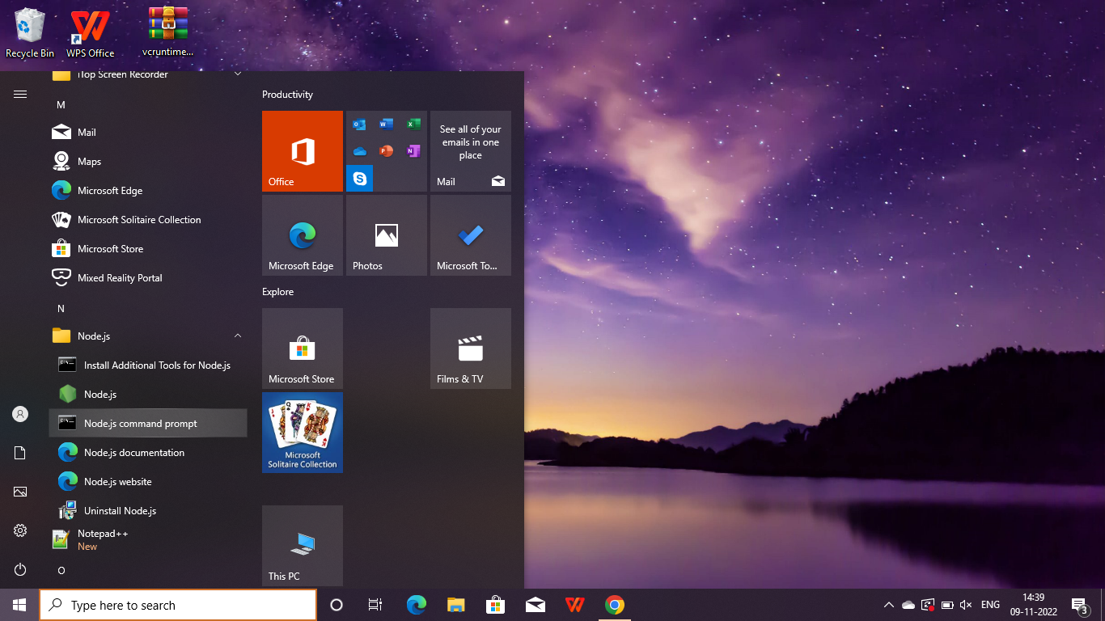

TYPE THE COMMAND >npm install -g --unsafe -perm node-red

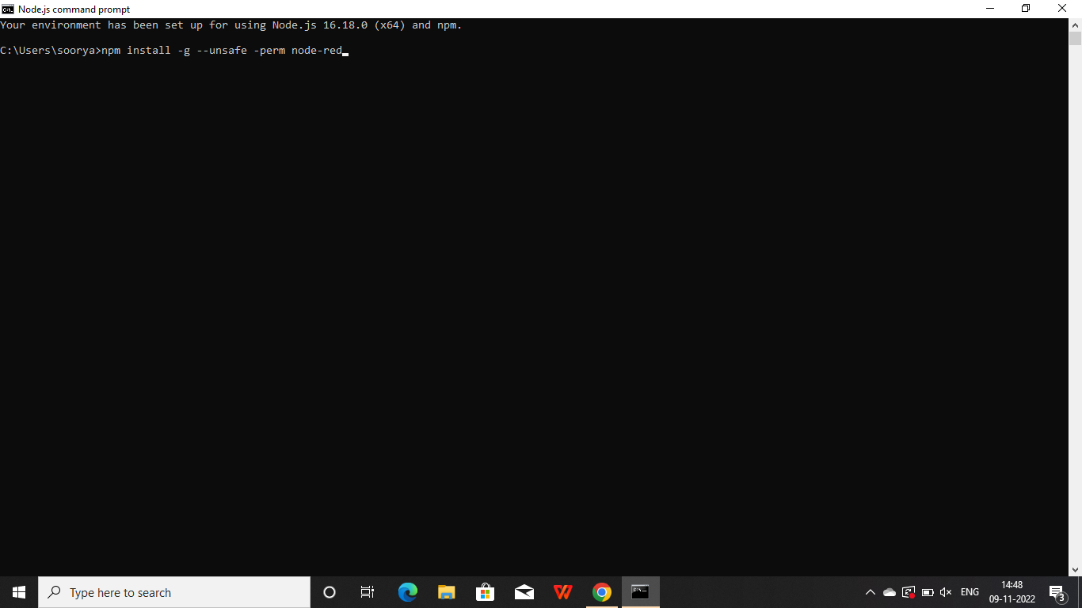

IT WILL INSTALL THE PACKAGES

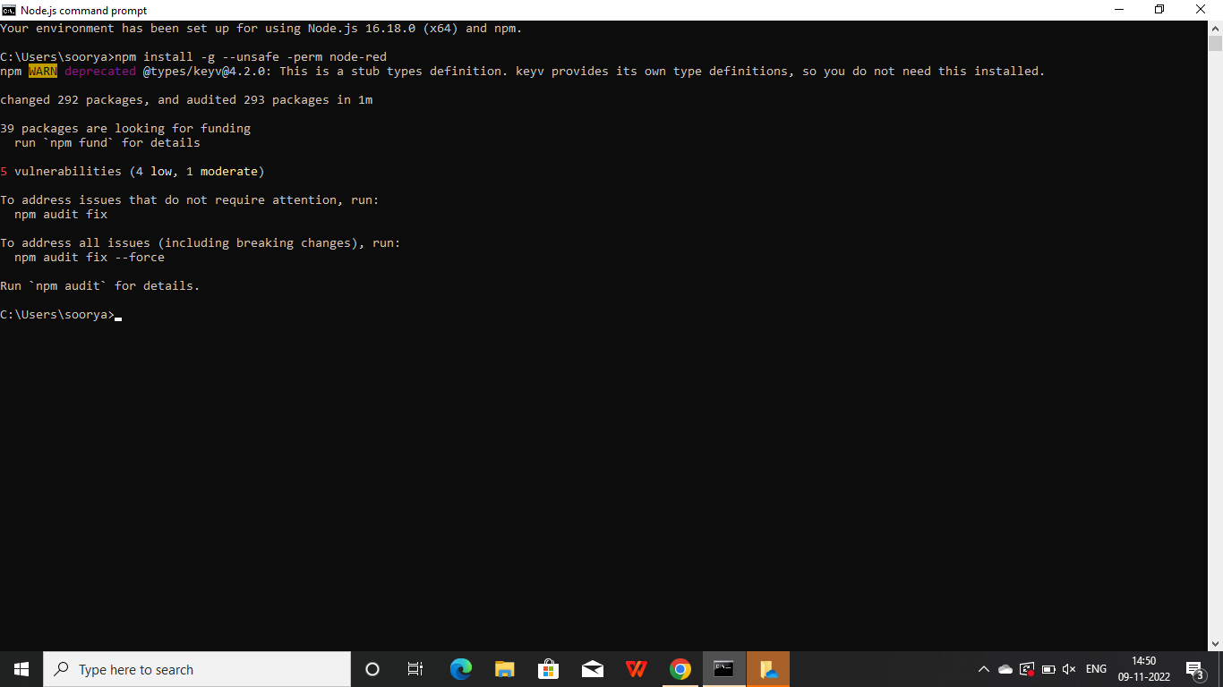

AND THEN TYPE >node-red. IT WILL SHOW THE VERSIONS AND DETAILS OF NODE-RED.

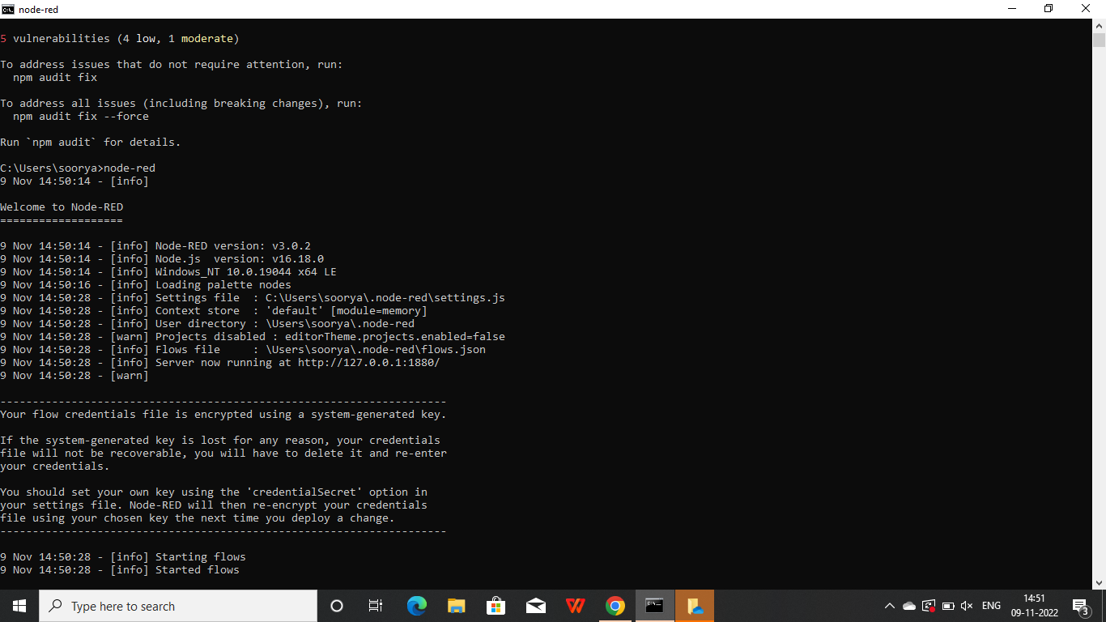

NOW WE CAN COPY THE ADDRESS AND GENERATE THE FLOW.

